<most of Lit Review>

NB: Include additional abbreviation: x:y, fatty acid nomenclature. x = length of carbon chain, y = number of double bonds.

Assembly – genome
- Raw Data:
  - A: C0M54ACXX: 100bp Paired End, 166483337 pairs
  - B₁: C0M86ACXX_ACAGTG: 100bp Paired End, 65211319 pairs
  - B₂: C0M86ACXX_TGACCA: 100bp Paired End, 73814559 pairs
  - C₁: COTO3ACXX_ACAGTG_L007: 100bp 174898671 pairs
  - C₂: COTO3ACXX_ACAGTG_L008: 100bp 179647464 pairs
  - C₃: COTO3ACXX_TGACCA_L005: 100bp
  - C₄: COTO3ACXX_TGACCA_L006:
  - X: CW1_NoIndex: 36bp MP, 130770079 pairs
  - S: Allpaths Scaffold

- Initially assembled using Velvet (parameter Sweep)
Defaults, n50=143bp, Longest=4346bp, Total=4978245 | 1x C0M54ACXX, 2x C0M86ACXX, 4x COTO3ACXX
Defaults, n50=224bp, Longest=11672bp, Total=3455751 | 1x C0M54ACXX, 2x C0M86ACXX, 4x COTO3ACXX, Kanga Filtered
Auto Coverage cutoff; n50=224bp, Longest=11672bp, Total=3455751 | 1x C0M54ACXX, 2x C0M86ACXX, 4x COTO3ACXX, 2x Mate Pair, Kanga Filtered
Auto Coverage cutoff, Insert Size 300, Mate pair specified; n50=307bp, Longest=17784bp, Total=3039111 | 1x C0M54ACXX, 2x C0M86ACXX, 4x COTO3ACXX, 2x Mate Pair
Auto Coverage cutoff, Insert Size 300, Mate pair specified; n50=327bp, Longest=17759bp, Total=2760513 | 1x C0M54ACXX, 2x C0M86ACXX, 4x COTO3ACXX, 2x Mate Pair, Kanga Filtered
Insert Size (PE)=180bp, Insert size (MP)=10kbp, Mate pair specified, Allpaths Assembly used as scaffold | 1x C0M54ACXX, 2x C0M86ACXX, 4x COTO3ACXX, 2x Mate Pair, Allpaths Scaffold
n50=764bp, Longest=106107bp, Total=2102531, Some large contigs, but many small ones

Assembly of Transcriptome

Trinity – check Barrine parameters

Also, have a look at Dissect, an algorithm designed to align

Thing to note – When aligning transcriptomic contigs against the genome, you have estimated that the average intron length in Safflower is 1500 bp, based on Arabidopsis (143 Mbp and average intron length of 173 bp) and Rice (433 Mbp, average intron length of 433) and a genome size of 1.4 Gbp (Reddy 2007). This is important for SNP discovery and determining the difference between s317 and WSRC03.

Gene Expression

Growth of plants and physiological measurements

S317 vs novel cultivars – Physiology and growth

Photoperiod experiment

Relationship between vernalisation and photoperiod
(extending the photoperiod experiment with vernalised and non-vernalised seedlings)

Coppicing and Pollarding
<is this actually going to happen?>

Safflower crossing with S317

Materials and Methods
- Imbibing in measuring cylinder
- 24 hour germination
- Half cotyledon sampled for FAME
  - NB: F₁ not sampled the same as F₂, think seriously about redoing the F₁ crosses
- Remainder of F₁ planted in glasshouse, F₂ in birdcage
- R code and calculations

Results

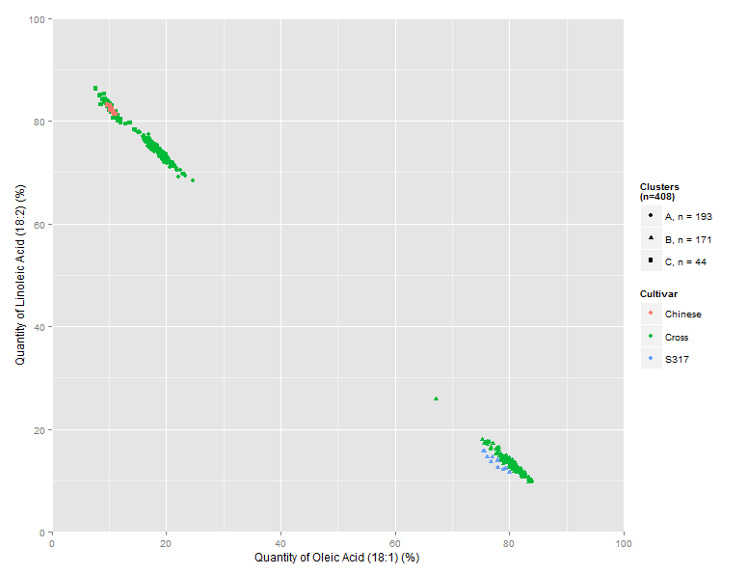
Figure X – Correlation of Oleic to Linoleic acid levels after FAME treatment in <154311.3>.7 and S317 F₂ crosses. Parental controls are included and categorised by colour. Cluster analysis groups are differentiated by shape. Number of events in each group does NOT include the 12 of each parent tested. The isolated data point above and behind the high Oleic cluster, while appearing to be an outlier, has been clustered with them.

Discussion

Looking at the results of Figure X above, the segregation of groups results in the ratios

 | AA | Aa | aA | aa
BB | AABB | AaBB | aABB | aaBB
Bb | AABb | AaBb | aABb | aaBb
bB | AAbB | AabB | aAbB | aabB
bb | AAbb | Aabb | aAbb | aabb

Table X.1 – The first pair of genes of a two-level Mendelian punnet square for the conversion of Oleic to Linoleic acid. Crossing events in green show an instance where a recursive gene is expressed in either gene A or gene B (p(aa|bb) = 7/16 = 43.75%). Events in yellow show instances where the dominant allele for gene A or gene B is expressed (p(A|B) = 9/16 = 56.25%). Those yellow events in bold show homozygous dominant events in either gene A or gene B with a dominant expression of the other gene (p((AA|BB)&!(aa|bb))= 5/16 = 31.25%).

 | CC | Cc | cC | cc
DD | CCDD | CcDD | cCDD | ccDD
Dd | CCDd | CcDd | cCDd | ccDd
dD | CCdD | CcdD | cCdD | ccdD
dd | CCdd | Ccdd | cCdd | ccdd

Table X.2 – The secondary pair of genes of a two-level Mendelian punnet square. In this case, genes C and D are only involved in the conversion of Oleic to Linoleic acid if genes A and B are dominantly expressed (see Table X.1 above, yellow). In this case, events where either gene C or D is homozygous dominant and the other is dominant (but not both) are in bold (p((CC&D)|(DD&C)) = 3/16 = 18.75%. The remainder of events are p(!(CC&D)|(DD&C) = 13/16 = 81.25%

Genetic Screen

